Recognized pattern: AndroRAT_variety1

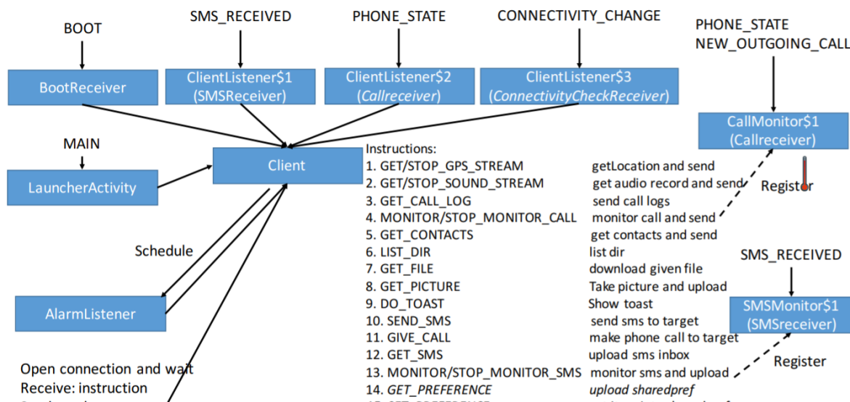

The corresponding sample app name: Framework

The corresponding app name: Gadgetbridge

For functional modules:

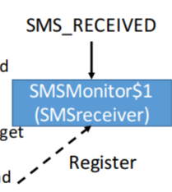

Corresponding to the corresponding key code in sample app:

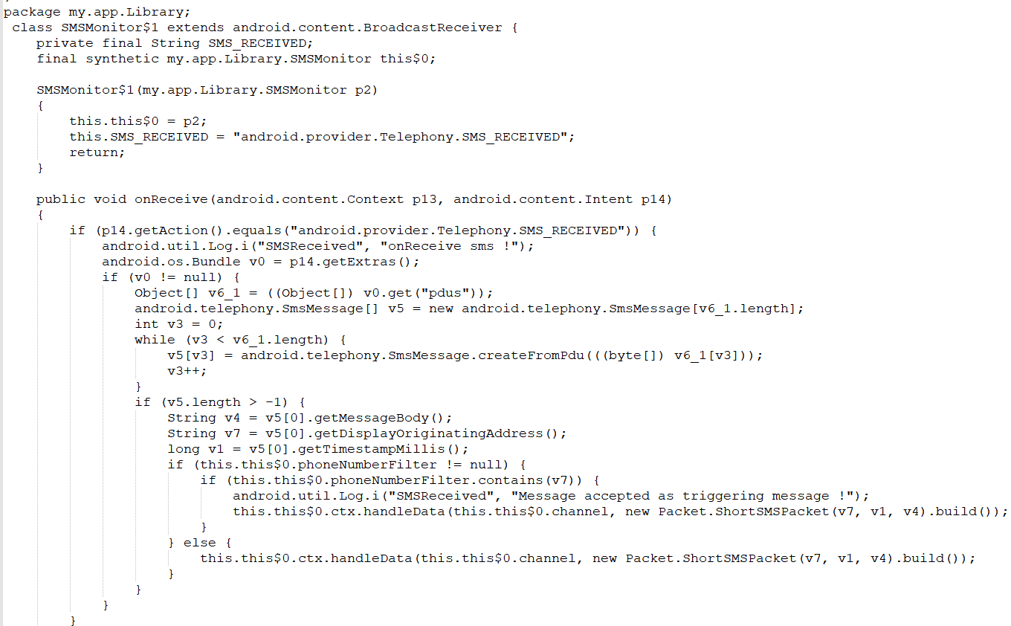

Corresponding to the key code in this app:

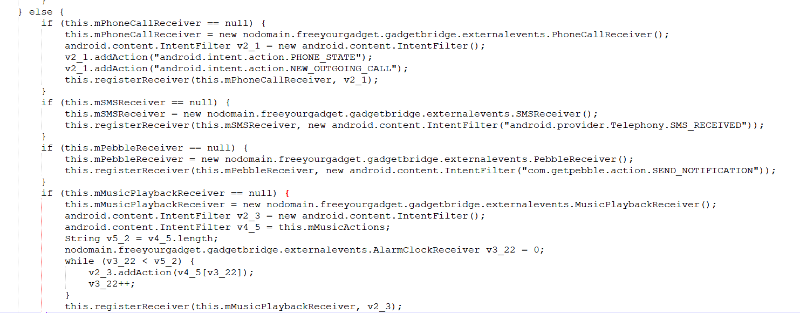

For functional modules:

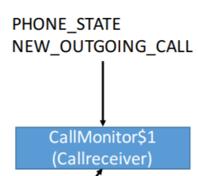

Corresponding to the key code in sample app:

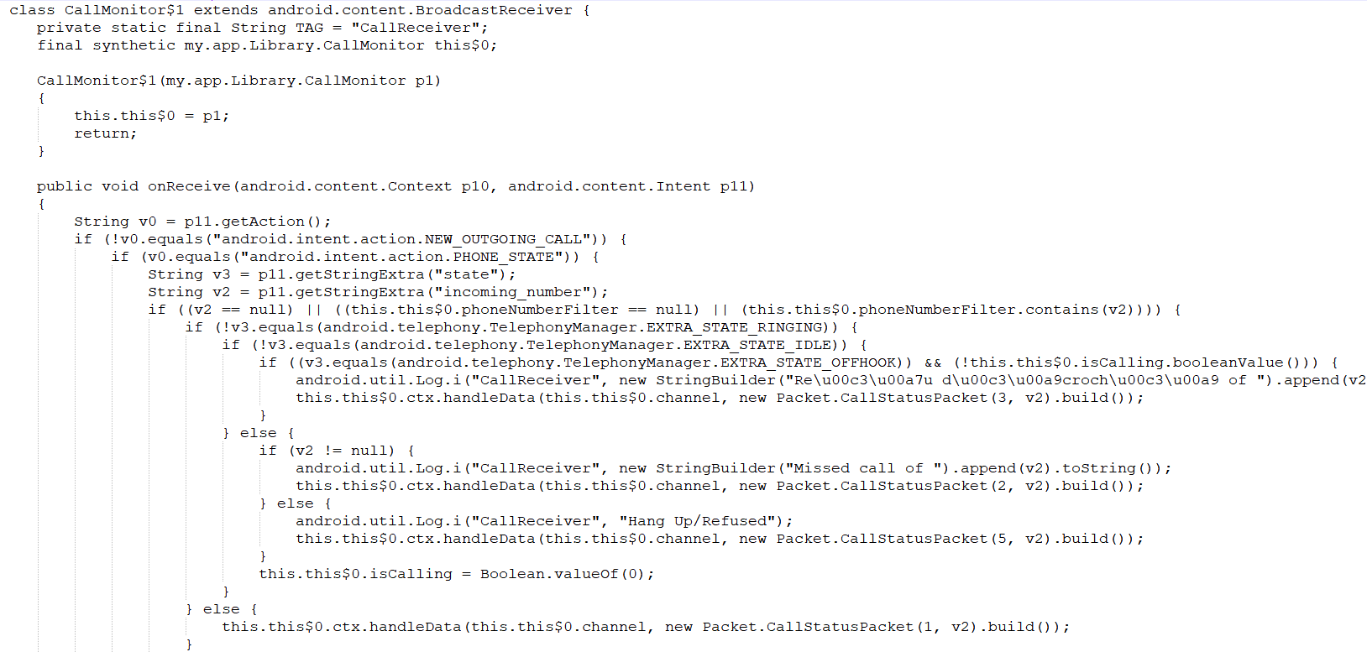

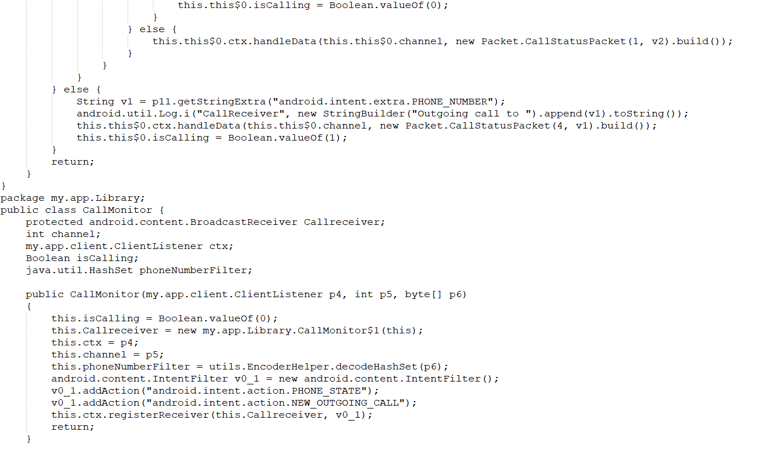

Corresponding to the key code in this app:

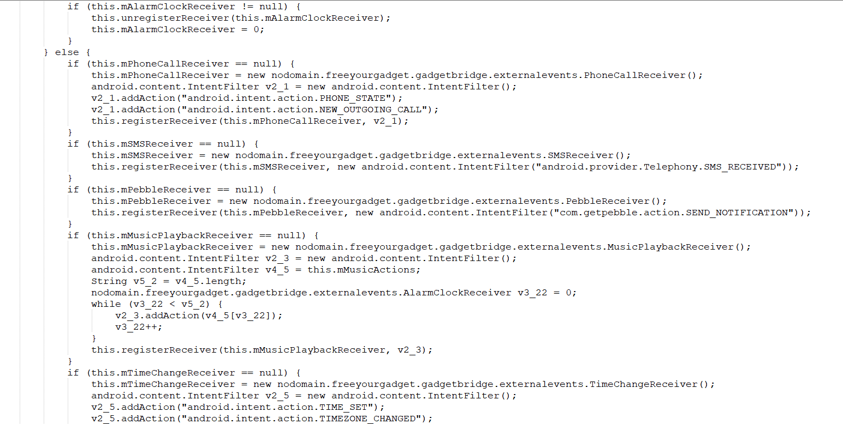

For function modules (obtaining information related to gps):

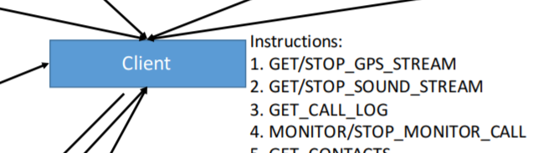

Corresponding to the key code in sample app:

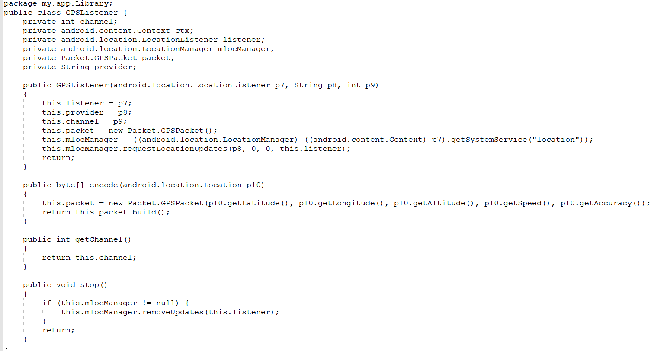

Corresponding to the key code in this app:

